1. Log into a Webminal - your username and password

* After Login, go to the following filepath: **cd /home/-{Your_Username_Here}-/Homework**

1. Check the directory name in which you are now.
2. Check the contents of your current directory.

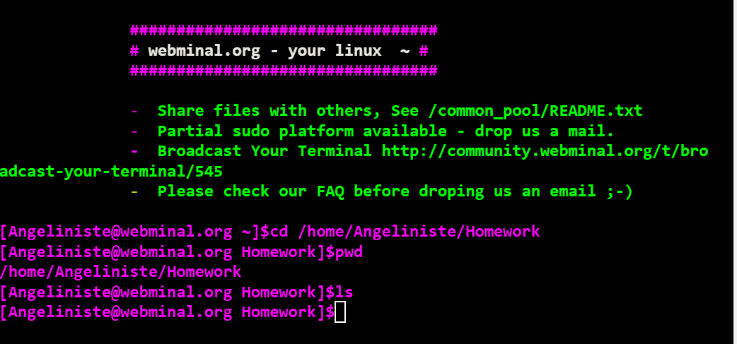

1. Create new directory **NameS**(name and the first letter of surname) in your current location.

* **Create folder**

1. Create two new files **file1** and **file2** in the newly created directory, and populate them with the days of the week (*file1*) and all the names of the months (*file2*).

3.Now list both of the files for confirmation that all data is correctly added to them:

1. Rename the two files as follows:
2. *file1* -> weekdays​
3. *file2* -> months

1. List fraction of data from both files:
2. List the first 4 lines from file *weekdays*.
3. Then list the last 6 lines from file *months*. (тука не се наведе декември, претпоставувам затоа што оставив два реда надолу)

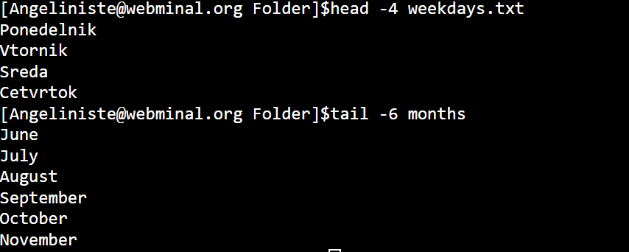

1. Create new directory **calendar** in the directory *NameS*.

* **Create folder**

1. A picture containing indoor

   Description automatically generatedMove file *months* to the new directory *calendar*.

# Next, remove the file *months* from *calendar* folder.

# A close up of a screen Description automatically generatedAs last step list all days from *weekdays* file which has “Sa” in them.